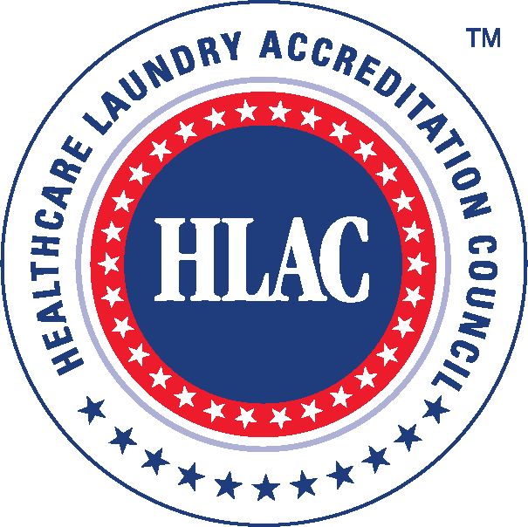
Healthcare Laundry Accreditation Council
ACCREDITATION INSPECTION AGREEMENT

(PLEASE READ: “HLAC ACCREDITATION INSPECTION PROCESS GUIDE”)

1st Time Applicant: _____ YES _____ NO

If applying for Reaccreditation, provide current Accreditation Expiration date: ______________

Please list desired timeframe (i.e., week of) to schedule the HLAC inspection: ______________

(Laundry Organizations due for reaccreditation can be inspected 60 days prior to and up to the expiration date of their current accreditation.)

I. LAUNDRY ORGANIZATION INFORMATION

Laundry Organization or Company Name: __________________________________________
Contact Person: _______________________________________________________________
Position or Title: _______________________________________________________________
Street Address: _______________________________________________________________
City, State, Zip: _______________________________________________________________
Country: _____________________________________________________________________
Telephone: _________________________________ Fax: _____________________________
Contact Person’s Cell Phone: ___________________ E-mail: __________________________ Is the invoice address the same as above? _____ YES _____ NO
If NO, please provide invoice address: _____________________________________________

II. DEMOGRAPHICS (Demographic information is held strictly confidential within HLAC)
- Type of laundry organization (please check one):
- Healthcare Textiles processed only __________
- Healthcare and Hospitality Textiles processed (Mixed Plant) __________
- Percentage of healthcare textiles processed at this location ______%
(Pounds: i.e., 50% healthcare, 50% non-healthcare)
- Of the healthcare textiles processed, please provide the following percentages:
- Acute care (hospital) __________%
- Long term care (nursing homes, etc.) _______%
- Retail medical (dental, ambulatory surgical, clinics) _________%
- Does this laundry organization have a surgical pack assembly room? ____ YES ____ NO
- Does this laundry organization sterilize textiles onsite? ____ YES ____ NO
- Age of laundry organization ________
- Square footage of this laundry organization __________
- Number of employees __________
- List how many full shifts __________
- List hours of operation by departments (if necessary, list on separate sheet)
__________________________________ __________________________________
__________________________________ __________________________________
- If you run a mixed laundry organization, list the hours when you process healthcare textiles
________________________________________________________________________
________________________________________________________________________
12. List hours of breaks and lunches by department (if necessary, list on separate sheet)
__________________________________ __________________________________
__________________________________ __________________________________
- Are there any days the laundry organization is not open during the next 45 days, including weekends and federal holidays? _______________________________________________
- List contact names and their cell phone numbers per shift, so that Inspectors do not have to search for individuals to answer questions (if necessary, list on separate sheet)
__________________________________ __________________________________
__________________________________ __________________________________
- Does this laundry organization have an offsite Depot (Associated with main processing facility)? ___ YES ___ NO
- If yes, provide the address of the depot(s) - (if necessary, list on separate sheet)
Depot #1: _____________________________________________________________
Depot #2: _____________________________________________________________
- If yes, what is the square footage of the offsite Depot(s)?
Depot #1: _____________________________________________________________
Depot #2: _____________________________________________________________
- What is the mileage between the main laundry organization and the offsite Depot?
Depot #1: _____________________________________________________________
Depot #2: _____________________________________________________________
If mileage is greater than a 10-mile radius, a $1,500 additional fee is required.
- How many hours away is the offsite depot to the main laundry organization?
Depot #1: _____________________________________________________________
Depot #2: _____________________________________________________________
If the depot is 3 hours or more away from the main facility, please add $300 to the depot inspection fee. If the depot is 6 hours or more away from the main facility, please add $600 to the depot inspection fee.

- Does this laundry organization process textiles entirely at one facility? ____ YES ____ NO If not, please explain: _______________________________________

- Has there been any major expansion and/or renovation (i.e., infrastructure versus capacity increase) to the laundry since the last HLAC inspection? ____ YES ____ NO
If YES, please explain (if necessary, list on separate sheet): _______________________
_________________________________________________________________________

III. LAUNDRY ORGANIZATION NAME ON PLAQUE AND HLAC WEBSITE

If accredited, please list the Laundry Organization Name as it is to appear on the Accreditation Plaque and the HLAC website: ________________________________________

If accredited, please list the Laundry Organization Web Address. A link to the Laundry Organization’s website will appear next to the Laundry Organization’s name on the HLAC website: ____________________________________________________________________

IV. INSPECTION FEES

In the table below, the basic inspection fees are listed. Specific detailed information related to the fees and processes are listed in the HLAC Accreditation Inspection Process Guide.

BASIC INSPECTION FEES*
(All monies are listed in U.S. currency)
 | United  States | Canada  Mexico
Countries outside North America, contact HLAC for fees
First Time Accreditation | $5,150 | $6,150
Renewal Accreditation | $5,150 | $6,150
Inspection for Depot (Associated with main processing facility greater than a 10-mile radius) | $1,500* | $1,500*
If the depot is 3 hours or more away from the main laundry facility, please add $300 to the depot inspection fee. | $300 | $300
If the depot is 6 hours or more away from the main laundry facility, please add $600 to the depot inspection fee. | $600 | $600
Remediation Visit ** | $2,500* | $2,500*
* Travel Expenses not included
** Remediation fees apply when a follow-up inspection is required to review corrective actions
Travel Expenses | Actual Expenses Incurred billed following the inspection
Inspection Rescheduling Fee  (If rescheduled less than 45 days before scheduled inspection plus any travel expenses, fees and penalties incurred by HLAC Inspector) | $500 | $500
*Laundry organizations in different countries, please call HLAC for the Basic Inspection Fee

V. SPECIAL RATES – MULTIPLE FACILITIES

In the table below, special rates are provided for laundry organizations with three or more facilities.

Special Rate for Laundry Organizations with Three or More Facilities*
(All monies are listed in U.S. currency)
To Qualify for the special rate, the laundry organization must submit the following:

- All agreements and Inspection Fees for all Facilities at the same time
- Provide proof of common ownership or management (i.e., articles of incorporation or letter from lawyer)
The following rates will be deducted from the Basic Inspection Rates Listed Above.
3 to 5 Laundry Facilities | $500 per Laundry Facility
6 to 10 Laundry Facilities | $750 per Laundry Facility
Over 10 Laundry Facilities | $1,000 per Laundry Facility
*For those laundry organizations with facilities in different countries, the country where the facility is located will determine the Basic Inspection Fee.

VI. HLAC ACCREDITATION AGREEMENT & PAYMENT

HLAC ACCREDITATION INSPECTION AGREEMENT & PAYMENT
Company Check Payable to: Healthcare Laundry Accreditation Council or HLAC
Mail HLAC Accreditation Inspection Agreement & Company Check to HLAC Lockbox:

Healthcare Laundry Accreditation Council
22640 Hazel Lane
Rapid City, SD 57430

For ACH Payments:
Financial Institution: PNC Bank
Account Name: Healthcare Laundry Accreditation Council
Routing Number: ABA 021052053
Account Number: 12792978

VII. HLAC RESPONSE TIMEFRAME

Due to the unique circumstances of each inspection, additional work and research may need to be completed before the HLAC Accreditation Sub-Committee can respond after an inspection or after receiving remediation (corrective) materials. This process can take up to three (3) weeks to complete.

VIII. HLAC UNANNOUNCED RE-INSPECTIONS

HLAC reserves the right to perform an unannounced re-inspection at an HLAC accredited laundry at any time during regular business hours which may affect its accreditation status. If the re-inspection shows that HLAC Standards are not met, accreditation may be revoked.

IX. HLAC POLICY - REACCREDITATIONS

Reaccreditation inspections can be scheduled 60 days prior to and up to the expiration date of their current accreditation expiration date. Laundry organizations that do not complete their reaccreditation during this timeframe will lose their accreditation.

On the day after their accreditation expiration date, the laundry organization’s name will be removed from the HLAC website and all marketing stating they are HLAC Accredited must be stopped immediately.

X. HLAC INSPECTION REMEDIATION (CORRECTIONS)

Remediation (corrections) may be allowed for laundry organizations that do not qualify for accreditation during its inspection depending upon the extent of the failures. The laundry organization will be allowed up to 15 business days from the date of the HLAC inspection results letter to remediate (correct) HLAC Standards failures; or in special circumstances, the Accreditation Sub-Committee may provide the laundry organization up to 45 days to remediate based on the extent of the remediation (corrections). Laundry organizations that do NOT submit remediation (corrections) within the designated time will have their accreditation revoked and will not be able to re- apply for accreditation for a period of six months.

XI. ACKNOWLEDGEMENT

By signing this agreement, the laundry organization agrees to the terms set forth in this document as well as the HLAC Accreditation Inspection Process Guide. It further acknowledges understanding of the HLAC Mission Statement, Inspection Process and Accreditation Standards for Processing Reusable Textiles for Use in Healthcare Facilities, 2016 Edition, as published on the HLAC’s website at www.hlacnet.org.

____________________________________ ___________________________________

Signed Printed Name

____________________________________ __________________________________
Date Title

For more information or questions, please contact:

Healthcare Laundry Accreditation Council (HLAC)
Toll Free: 855-277-HLAC (4522)
Telephone: 815-436-1404
www.hlacnet.org

