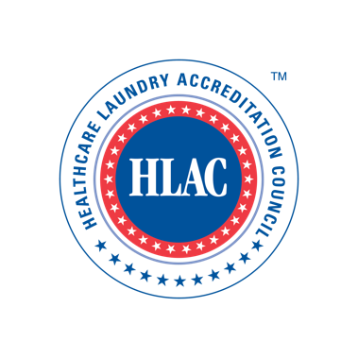
Healthcare Laundry Accreditation Council

Inspector Application

Thank you for applying for an HLAC Inspector position

Please provide the following information:

CONTACT INFORMATION

Application Date
Name
Title
Organization
Street Address
City/State/Zip Code
Country
Work Phone
Work Fax
Work E-Mail
Cell Phone
Home Street Address
City/State/Zip Code
Country
Home Phone
Home Fax (if applicable)
Home E-Mail (if applicable)

LANGUAGE (Please mark all that apply)

_____ French/English; _____ Spanish/English; _____ English

EDUCATION (Please list all Degrees) [If necessary, list on separate sheet]

ADDITIONAL CREDENTIALS (Please list all credentials, certifications or licensures) [If necessary, list on separate sheet]

HEALTHCARE INDUSTRY EXPERIENCE (Summarize your experience in the healthcare industry) [If necessary, list on separate sheet]

HEALTHCARE LAUNDRY WORK EXPERIENCE (Summarize your healthcare laundry experience, including number of years. Please list in reverse chronological order with current status listed first.) [If necessary, list on separate sheet]

OTHER HEALTHCARE RELATED ACTIVITIES (Can include, but not limited to, participation in other healthcare organizations or hospitals/healthcare committees and task forces) [If necessary, list on separate sheet]

WHY DO YOU WISH TO BECOME AN HLAC INSPECTOR? (Summarize your rationale, strengths and talents to be an HLAC Inspector) [If necessary, list on separate sheet]

PEER REFERENCES [CANNOT BE CURRENT HLAC BOARD MEMBERS OR INSPECTORS]: (Please provide the names of at least three (3) references with a minimum of two professional references. Select industry-relevant associates who can attest to your skills and qualities.)

PEER REFERENCE #1

Name (printed)
Title/Company
Telephone Number
Cell Phone Number
E-mail Address
PEER REFERENCE #2

Name (printed)
Title/Company
Telephone Number
Cell Phone Number
E-mail Address
PEER REFERENCE #3

Name (printed)
Title/Company
Telephone Number
Cell Phone Number
E-mail Address

APPLICANT’S FACILITY – ACCREDITED?

If you own or manage a healthcare facility, is it accredited? ______ YES ______ NO

If yes, please indicate accreditation date. _____________________

If no, does the facility plan to become accredited? ______ YES ______ NO

AGREEMENT SIGNATURE
By submitting this application, I have read and understand the requirements for serving as an HLAC Inspector and shall fulfill the responsibilities and commitments of an HLAC Inspector to the best of my ability and as outlined in the HLAC Inspector Independent Contractor Agreement. I agree to have my name, biographical information, and picture published on the HLAC website.

Name (printed)

Signature

Date

APPLICATION AND PHOTO SUBMISSION AND DEADLINE
Please submit this application no later than October 17, 2022, online or mail hard copies to:

HLAC
22640 Hazel Lane
Rapid City, SD 57702

Your PHOTO (as a .jpg) and any additional information you wish the hiring committee to review (i.e., resume) are also due by October 17, 2022; email to admin@hlacnet.org

Individuals chosen as HLAC inspectors must attend a mandatory Inspectors Training session on November 14, 2022.

HLAC POLICY
The HLAC policy is to provide equal opportunities without regard to race, color, religion, national origin, gender, sexual preference, age, or disability.

Thank you for completing this application form.

